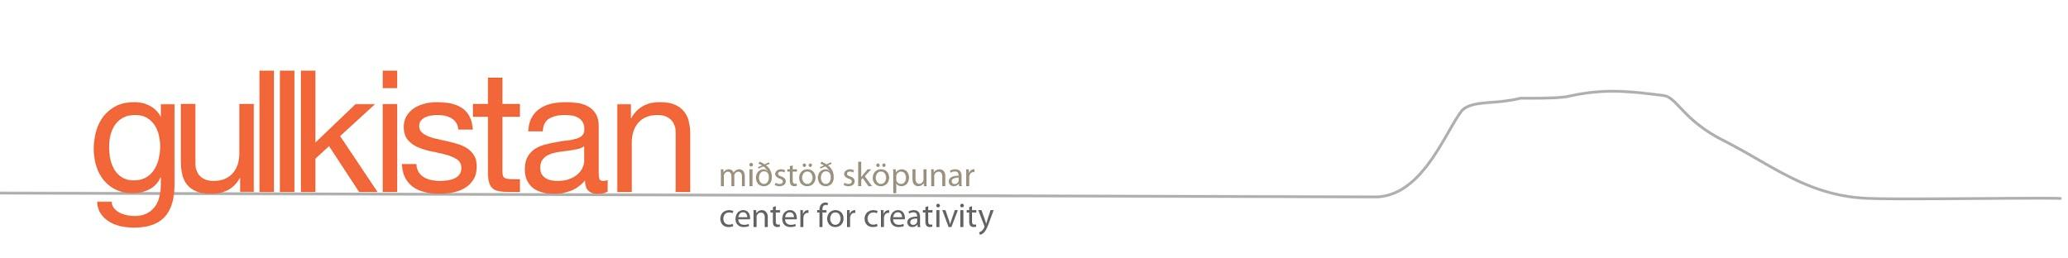

Application form
The residency program is open to professionally established artists of all fields and academics of all professions. Minimum stay is 1 month. We speak English, spanish, french and scandinavian. Applications will be answered as soon as possible.

Date of application:

Name: Professional title:
(visual art, music, composer)
Gender: Year of Birth: E-mail:

Telephone: Webpage:

Address: City:

Country:

I am applying for:
______________________________________________________________
950 € Single room, one studio space included
1150 € Double room, one studio space included
1450 € Double room with extra studio space

Period requested: Minimum stay is one month
1st choice:
2nd choice:
3rd choice:

Pleace send as attachments to gullkistan@gullkistan.is:
C.V. - Curriculum Vitae
Aim of stay.

Are you ready to present your work in some way for the public during your stay?
How/where did you learn about Gullkistan?

